**МИНОБРНАУКИ РОССИИ**

федеральное государственное бюджетное образовательное учреждение

высшего образования

**«Санкт-Петербургский государственный технологический институт (технический университет)»**

**(СПбГТИ(ТУ))**

Факультет **Информационных технологий и управления**

Кафедра **Систем автоматизированного проектирования и управления**

Дисциплина **Технология разработки программного обеспечения**

**Лабораторная работа №4**

# **Тема: организация множественных прикладных сред с использованием системы виртуальных машин**

# **разработка интерфейса к бд**

Захаренко К.А.

Комарова И. А.

Группа № 4811М

Проверили:

Корниенко И.Г.

Федин А.К.

Санкт-Петербург

2018

**Цель работы**

В данной работе предлагается получить навыки создания систем, поддерживающих идею множественных прикладных сред, воспользовавшись программным обеспечением системы виртуальных машин.

**Результаты по организации виртуальной машины**

Загрузки



Рисунок 1 – Главное окно программы Oracle VM VirtualBox

Создание виртуальной машины



Рисунок 2 – Выбор ОС

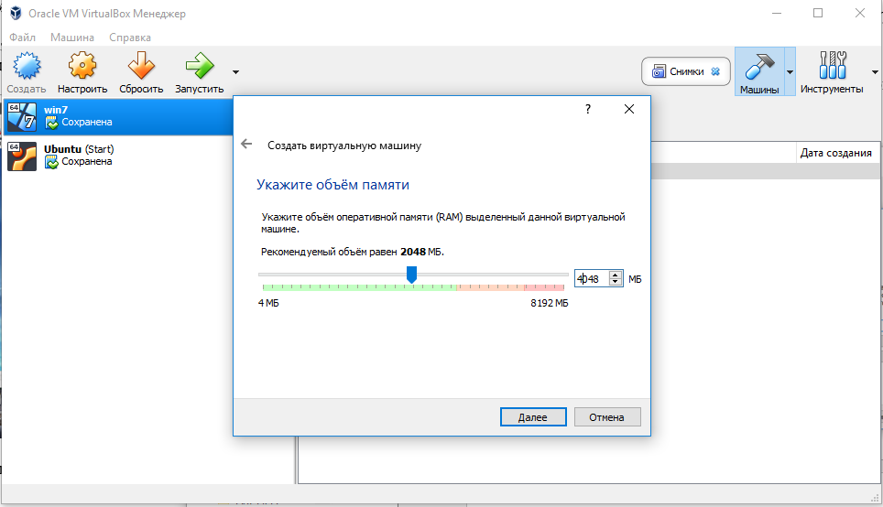

Рисунок 3 – Выбор объема памяти

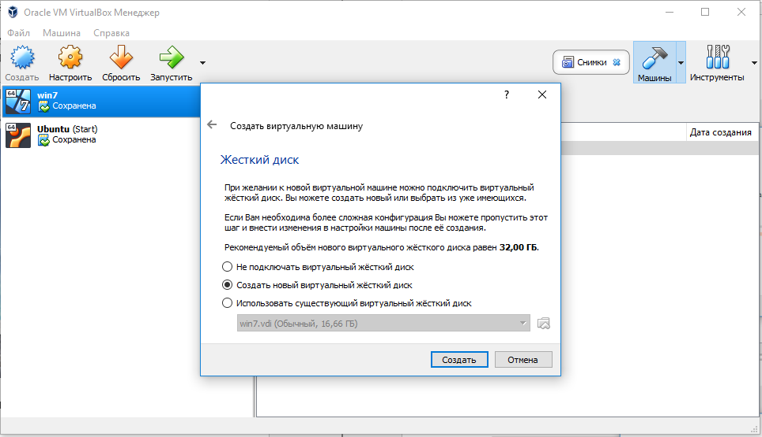

Рисунок 4 – Подключение ЖД

Рисунок 5 – Тип ЖД



Рисунок 6 – Формат хранения



Рисунок 7 – Имя и размер ЖД

Инсталляция гостевой операционной системы

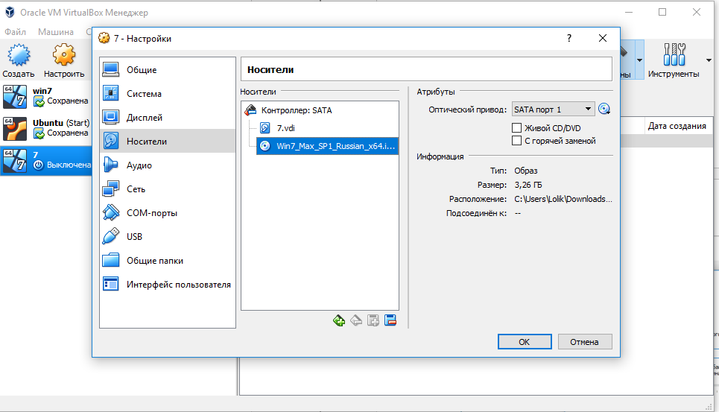

Рисунок 8 – Настройки виртуальной машины



Рисунок 9 – Установка ОС на виртуальную машину

Работа на виртуальной машине



Рисунок 10 – Работа на виртуальной машине

**Листинг разработанной программы для связи с БД**

public partial class Form10 : Form

{

public class ComboBoxKostyl

{

public string id;

public string name;

public override string ToString()

{

return name;

}

}

public static Form10 instance;

public string id_man;

bool updateVars = false;

public Form10()

{

// InitializeComponent();

instance = this;

InitializeComponent();

updateVars = true;

SQLiteCommand command = new SQLiteCommand("select * from type_eq", Form1.instance.BD);

DbDataReader reader = command.ExecuteReader();

while (reader.Read())

{

typ.Items.Add(new ComboBoxKostyl() { id = reader["ID_type"].ToString(), name = reader["Name_type"].ToString() });

// typ.Items.Add(new { id_type = reader["ID_type"].ToString(), name_eq = reader["Name_type"].ToString() });

}

DataSet ds = new DataSet();

string sql = "SELECT ID_eq, Name_eq FROM equipment";

dataGridView1.RowPostPaint += dataGridView1_RowPostPaint;

SQLiteCommand comm = new SQLiteCommand(sql, Form1.instance.BD);

using (SQLiteDataReader read = comm.ExecuteReader())

{

while (read.Read())

{

dataGridView1.Rows.Add(new object[] {

read.GetValue(1),

});

dataGridView1.Rows[dataGridView1.Rows.Count - 1].Tag = read.GetValue(0);

}

}

dataGridView1.SelectionChanged += new EventHandler(dataGridView1_SelectionChanged);

updateVars = false;

}

private void dataGridView1_RowPostPaint(object sender, DataGridViewRowPostPaintEventArgs e)

{

var grid = sender as DataGridView;

var centerFormat = new StringFormat()

{

Alignment = StringAlignment.Center,

LineAlignment = StringAlignment.Center

};

var headerBounds = new Rectangle(e.RowBounds.Left, e.RowBounds.Top, grid.RowHeadersWidth, e.RowBounds.Height);

}

private void dataGridView1_SelectionChanged(object sender, EventArgs e)

{

updateVars = true;

/* string sql = String.Format("SELECT manufactory.Name_man, manufactory.Length_man, manufactory.Width_man, manufactory.Hight_man, " +

"manufactory.Performance, manufactory.Energy, manufactory.Cost, manufactory.Path_man, " +

"Group_Concat(extrusion_line.Name, ', ') FROM composition_man JOIN manufactory ON " +

"manufactory.ID_man=composition_man.ID_man JOIN extrusion_line ON composition_man.ID_line=extrusion_line.ID_line"); */

string sql = "SELECT equipment.Name_eq, type_eq.Name_type, equipment.Length_eq, equipment.Width_eq, " +

"equipment.Hight_eq, equipment.Cost, equipment.Path_eq, equipment.link_eq, equipment.ID_eq FROM equipment JOIN type_eq ON equipment.ID_type = type_eq.ID_type";

dataGridView1.SelectedRows[0].Tag.ToString();

sql += " WHERE equipment.ID_eq = " + dataGridView1.SelectedRows[0].Tag.ToString();

DataSet ds = new DataSet();

SQLiteCommand comm = new SQLiteCommand(sql, Form1.instance.BD);

using (SQLiteDataReader read = comm.ExecuteReader())

{

while (read.Read())

{

Name_eq.Text = read.GetString(0);

//typ.SelectedValue = read.GetValue(1);

//typ.SelectedItem = read.GetValue(1);

string desiredType = read.GetValue(1).ToString();

foreach (ComboBoxKostyl item in typ.Items)

{

if (item.name.Equals(desiredType))

{

typ.SelectedItem = item;

break;

}

}

Length.Value = (decimal)read.GetDouble(2);

Width.Value = (decimal)read.GetDouble(3);

High.Value = (decimal)read.GetDouble(4);

cost.Value = (decimal)read.GetDouble(5);

path.Text = read.GetString(6);

model.Text = read.GetString(7);

}

}

SQLiteCommand CMD = Form1.instance.BD.CreateCommand();

//ПРОИЗВОДИТЕЛЬНОСТЬ

CMD.CommandText = "SELECT equipment_param_eq.value AS PER FROM param_eq JOIN equipment_param_eq ON " +

"param_eq.ID_param=equipment_param_eq.ID_param WHERE equipment_param_eq.ID_param =1 AND equipment_param_eq.ID_eq = " + "'" + dataGridView1.SelectedRows[0].Tag.ToString() + "'";

//string p = CMD.ExecuteScalar().ToString();

//per.Value = Decimal.Parse(p);

//per.Value = Decimal.Parse(CMD.ExecuteScalar().ToString());

per.Value = Convert.ToDecimal(CMD.ExecuteScalar().ToString());

//label2.Text = per.Value.ToString();

// per.Value = (decimal)CMD.ExecuteScalar();

//ЭНЕРГОПОТРЕБ

CMD.CommandText = "SELECT equipment_param_eq.value AS PER FROM param_eq JOIN equipment_param_eq ON " +

"param_eq.ID_param=equipment_param_eq.ID_param WHERE equipment_param_eq.ID_param =2 AND equipment_param_eq.ID_eq = " + "'" + dataGridView1.SelectedRows[0].Tag.ToString() + "'";

// energy.Text = CMD.ExecuteScalar().ToString();

energy.Value = Convert.ToDecimal(CMD.ExecuteScalar().ToString());

updateVars = false;

}

private void Name_eq_TextChanged(object sender, EventArgs e)

{

if (!updateVars)

{

SQLiteCommand CMD = Form1.instance.BD.CreateCommand();

CMD.CommandText = "UPDATE equipment SET Name_eq = " + "'" + Name_eq.Text + "'" + " WHERE ID_eq = " + dataGridView1.SelectedRows[0].Tag.ToString();

CMD.ExecuteNonQuery();

dataGridView1.SelectedRows[0].Cells[0].Value = Name_eq.Text;

}

}

private void typ_SelectedIndexChanged(object sender, EventArgs e)

{

if (!updateVars)

{

SQLiteCommand CMD = Form1.instance.BD.CreateCommand();

CMD.CommandText = "UPDATE equipment SET ID_type= " + "'" + (typ.SelectedItem as ComboBoxKostyl).id + "'" + " WHERE ID_eq = " + dataGridView1.SelectedRows[0].Tag.ToString();

CMD.ExecuteNonQuery();

}

}

private void Length_ValueChanged(object sender, EventArgs e)

{

if (!updateVars)

{

SQLiteCommand CMD = Form1.instance.BD.CreateCommand();

CMD.CommandText = "UPDATE equipment SET Length_eq = " + "'" + Length.Value.ToString().ToLower().Replace(",", ".") + "'" + " WHERE ID_eq = " + dataGridView1.SelectedRows[0].Tag.ToString();

CMD.ExecuteNonQuery();

}

}

private void Width_ValueChanged(object sender, EventArgs e)

{

if (!updateVars)

{

SQLiteCommand CMD = Form1.instance.BD.CreateCommand();

CMD.CommandText = "UPDATE equipment SET Width_eq = " + "'" + Width.Value.ToString().ToLower().Replace(",", ".") + "'" + " WHERE ID_eq = " + dataGridView1.SelectedRows[0].Tag.ToString();

CMD.ExecuteNonQuery();

}

}

private void High_ValueChanged(object sender, EventArgs e)

{

if (!updateVars)

{

SQLiteCommand CMD = Form1.instance.BD.CreateCommand();

CMD.CommandText = "UPDATE equipment SET Hight_eq = " + "'" + High.Value.ToString().ToLower().Replace(",", ".") + "'" + " WHERE ID_eq = " + dataGridView1.SelectedRows[0].Tag.ToString();

CMD.ExecuteNonQuery();

}

}

private void cost_ValueChanged(object sender, EventArgs e)

{

if (!updateVars)

{

SQLiteCommand CMD = Form1.instance.BD.CreateCommand();

CMD.CommandText = "UPDATE equipment SET Cost = " + "'" + cost.Value.ToString().ToLower().Replace(",", ".") + "'" + " WHERE ID_eq = " + dataGridView1.SelectedRows[0].Tag.ToString();

CMD.ExecuteNonQuery();

}

}

private void per_ValueChanged(object sender, EventArgs e)

{

if (!updateVars)

{

SQLiteCommand CMD = Form1.instance.BD.CreateCommand();

//ПРОИЗВОДИТЕЛЬНОСТЬ

CMD.CommandText = "UPDATE equipment_param_eq SET value = " + "'" + per.Value.ToString().ToLower().Replace(",", ".") + "'" + " WHERE ID_param=1 AND ID_eq=" + dataGridView1.SelectedRows[0].Tag.ToString() ;

CMD.ExecuteNonQuery();

// per.Text = CMD.ExecuteScalar().ToString();

}

}

private void energy_ValueChanged(object sender, EventArgs e)

{

if (!updateVars)

{

SQLiteCommand CMD = Form1.instance.BD.CreateCommand();

//energyyy

CMD.CommandText = "UPDATE equipment_param_eq SET value = " + "'" + energy.Value.ToString().ToLower().Replace(",", ".") + "'" + " WHERE ID_param=2 AND ID_eq=" + dataGridView1.SelectedRows[0].Tag.ToString();

CMD.ExecuteNonQuery();

// per.Text = CMD.ExecuteScalar().ToString();

}

}

private void path_TextChanged(object sender, EventArgs e)

{

if (!updateVars)

{

SQLiteCommand CMD = Form1.instance.BD.CreateCommand();

CMD.CommandText = "UPDATE equipment SET Path_eq = " + "'" + path.Text + "'" + " WHERE ID_eq = " + dataGridView1.SelectedRows[0].Tag.ToString();

CMD.ExecuteNonQuery();

}

}

private void model_TextChanged(object sender, EventArgs e)

{

if (!updateVars)

{

SQLiteCommand CMD = Form1.instance.BD.CreateCommand();

CMD.CommandText = "UPDATE equipment SET link_eq = " + "'" + model.Text + "'" + " WHERE ID_eq = " + dataGridView1.SelectedRows[0].Tag.ToString();

CMD.ExecuteNonQuery();

}

}

private void Form10_FormClosing(object sender, FormClosingEventArgs e)

{

//костыль, запись всех ид в лист

string sql = "SELECT ID_eq FROM equipment"; ;

SQLiteCommand comm = new SQLiteCommand(sql, Form1.instance.BD);

List<string> IDeq = new List<string>();

using (SQLiteDataReader read = comm.ExecuteReader())

{

while (read.Read())

{

IDeq.Add(read[0].ToString());

}

}

for (int l = 0; l < IDeq.Count; l++)

{

SQLiteCommand CMD1 = Form1.instance.BD.CreateCommand();

CMD1.CommandText = "SELECT Length_eq FROM equipment " + "'" + IDeq[l] + "'";

SQLiteCommand CMD2 = Form1.instance.BD.CreateCommand();

CMD2.CommandText = "SELECT Width_eq FROM equipment " + "'" + IDeq[l] + "'";

SQLiteCommand CMD3 = Form1.instance.BD.CreateCommand();

CMD3.CommandText = "SELECT Hight_eq FROM equipment " + "'" + IDeq[l] + "'";

SQLiteCommand CMD4 = Form1.instance.BD.CreateCommand();

CMD4.CommandText = "SELECT Cost FROM equipment " + "'" + IDeq[l] + "'";

SQLiteCommand CMD5 = Form1.instance.BD.CreateCommand();

CMD5.CommandText = "SELECT equipment_param_eq.value AS PER FROM param_eq JOIN equipment_param_eq ON " +

"param_eq.ID_param=equipment_param_eq.ID_param WHERE equipment_param_eq.ID_param =1 AND equipment_param_eq.ID_eq = " + "'" + IDeq[l] + "'";

SQLiteCommand CMD6 = Form1.instance.BD.CreateCommand();

CMD6.CommandText = "SELECT equipment_param_eq.value AS PER FROM param_eq JOIN equipment_param_eq ON " +

"param_eq.ID_param=equipment_param_eq.ID_param WHERE equipment_param_eq.ID_param =2 AND equipment_param_eq.ID_eq = " + "'" + IDeq[l] + "'";

if (Convert.ToDouble(CMD1.ExecuteScalar()) == 0 || Convert.ToDouble(CMD2.ExecuteScalar()) == 0 || Convert.ToDouble(CMD3.ExecuteScalar()) == 0 ||

Convert.ToDouble(CMD4.ExecuteScalar()) == 0 || Convert.ToDouble(CMD5.ExecuteScalar()) == 0 || Convert.ToDouble(CMD6.ExecuteScalar()) == 0 )

{

MessageBox.Show("Значения не должны быть нулевыми!", "ОШИБКА!", MessageBoxButtons.OK, MessageBoxIcon.Error);

e.Cancel = true;

break;

}

SQLiteCommand CMD7 = Form1.instance.BD.CreateCommand();

CMD7.CommandText = "SELECT Name_eq FROM equipment WHERE ID_eq= " + "'" + IDeq[l] + "'";

SQLiteCommand CMD8 = Form1.instance.BD.CreateCommand();

CMD8.CommandText = "SELECT Path_eq FROM equipment WHERE ID_eq= " + "'" + IDeq[l] + "'";

SQLiteCommand CMD9 = Form1.instance.BD.CreateCommand();

CMD9.CommandText = "SELECT link_eq FROM equipment WHERE ID_eq= " + "'" + IDeq[l] + "'";

if (CMD7.ExecuteScalar().ToString() == "" || CMD8.ExecuteScalar().ToString() == "" || CMD9.ExecuteScalar().ToString() == "")

{

MessageBox.Show("Заполните все поля!", "ОШИБКА!", MessageBoxButtons.OK, MessageBoxIcon.Error);

e.Cancel = true;

break;

}

}

}

private void button2_Click(object sender, EventArgs e)

{

dataGridView1.Rows.Add("Оборудование");

SQLiteCommand CMD = Form1.instance.BD.CreateCommand();

CMD.CommandText = "INSERT INTO equipment(Name_eq, Length_eq, Width_eq, Hight_eq, Cost, " +

"Path_eq, link_eq, ID_type) VALUES ('Оборудование', '0', '0', '0', '0', '/path', 'link', 1)";

CMD.ExecuteNonQuery();

DataSet ds = new DataSet();

string sql = "SELECT MAX(ID_eq) FROM equipment";

SQLiteCommand comm = new SQLiteCommand(sql, Form1.instance.BD);

var id = comm.ExecuteScalar();

dataGridView1.Rows[dataGridView1.Rows.Count - 1].Tag = id;

CMD.CommandText = "INSERT INTO equipment_param_eq(value, ID_param, ID_units, ID_eq) VALUES ('0', 1, 1, " + "'" + id + "'"+ ")" ;

CMD.ExecuteNonQuery();

CMD.CommandText = "INSERT INTO equipment_param_eq(value, ID_param, ID_units, ID_eq) VALUES ('0', 2, 1, " + "'" + id + "'" + ")";

CMD.ExecuteNonQuery();

}

private void button3_Click(object sender, EventArgs e)

{

SQLiteCommand CMD = Form1.instance.BD.CreateCommand();

CMD.CommandText = "DELETE FROM equipment WHERE ID_eq = " + dataGridView1.Rows[dataGridView1.SelectedRows[0].Index].Tag;

CMD.ExecuteNonQuery();

CMD.CommandText = "DELETE FROM composition_line WHERE ID_eq = " + dataGridView1.Rows[dataGridView1.SelectedRows[0].Index].Tag;

CMD.ExecuteNonQuery();

CMD.CommandText = "DELETE FROM equipment_param_eq WHERE ID_eq = " + dataGridView1.Rows[dataGridView1.SelectedRows[0].Index].Tag;

CMD.ExecuteNonQuery();

dataGridView1.Rows.RemoveAt(dataGridView1.SelectedRows[0].Index);

}

private void Form10_FormClosed(object sender, FormClosedEventArgs e)

{

Form1.instance.updatePerformance();

Form1.instance.update_cex();

Form1.instance.updateTable2();

Form1.instance.updateTable();

Form1.instance.updateTable3();

}

}